FINAL REPORT Plugging into the Future: An Exploration of Electricity Consumption Patterns Using Tableau

1. INTRODUCTION

1.1 Project Overview
Electricity consumption analysis plays a crucial role in understanding energy demand, optimizing power distribution, and promoting sustainable energy usage. With increasing electricity demand across residential, commercial, and industrial sectors, there is a need for effective analytical tools to interpret large volumes of consumption data. This project focuses on analyzing electricity consumption patterns using Tableau, an interactive data visualization platform. The goal is to transform raw electricity usage data into meaningful insights that support energy planning and decision-making.

1.2 Purpose
The purpose of this project is to analyze electricity consumption trends and visualize them in an interactive and user-friendly manner. By leveraging Tableau, the project helps stakeholders identify peak demand periods, seasonal variations, regional usage differences, and overall consumption trends.

2. IDEATION PHASE

2.1 Problem Statement
To design an interactive Tableau dashboard that enables analysis of electricity consumption patterns across time, seasons, and regions, helping stakeholders make informed energy management decisions.

2.2 Empathy Map Canvas
The project was developed by understanding the needs of energy analysts and policymakers:
- Think: How can electricity usage patterns be understood easily?
- Feel: Concerned about rising demand and inefficient energy usage.
- Say: “I need clear insights to plan electricity distribution.”
- Frustration: Difficulty in analyzing complex and large datasets.
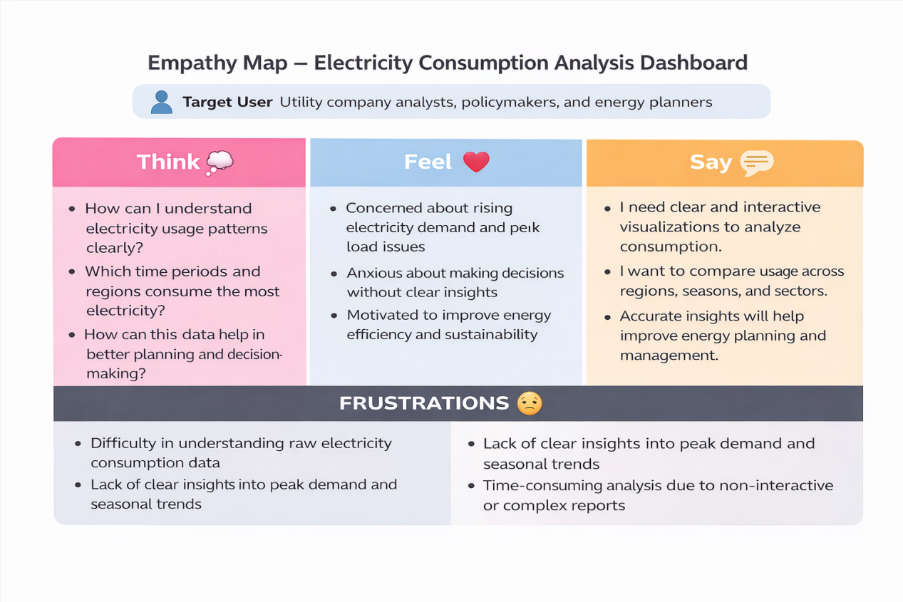

2.3 Brainstorming
The following ideas were generated:
- Analyzing time-of-day electricity usage
- Identifying seasonal consumption trends
- Comparing regional electricity demand
- Detecting peak and off-peak usage periods
- Creating interactive dashboards with filters

3. REQUIREMENT ANALYSIS

3.1 Customer Journey Map
Stage | Action | Tool | Emotion | Opportunity
Discover | User accesses dashboard | Tableau | Curious | Engage with visuals
Explore | Applies filters | Filters | Interested | Improve insights
Analyze | Observes trends | Charts | Confident | Better decisions
Share | Shares dashboard | Web link | Satisfied | Wider impact

3.2 Solution Requirements

Electricity consumption dataset

SQL database for storage

Tableau for visualization

Charts: line, bar, area graphs

Filters: time, season, region

3.3 Data Flow Diagram
Electricity data flows from public datasets into an SQL database, undergoes preprocessing and aggregation, and is then visualized in Tableau dashboards. The dashboards are embedded into a web interface for stakeholder access.

3.4 Technology Stack

Frontend: Tableau Public, HTML

Backend: SQL

Preprocessing: Excel / Python

Data Source: Kaggle electricity datasets

4. PROJECT DESIGN

4.1 Problem–Solution Fit
Raw electricity data is difficult to interpret. The proposed solution simplifies analysis through visual dashboards that clearly represent trends and patterns.

4.2 Proposed Solution : An interactive Tableau dashboard that provides:
- Electricity consumption over time
- Seasonal demand analysis
- Regional usage comparison
- Peak and off-peak demand identification

4.3 Solution Architecture
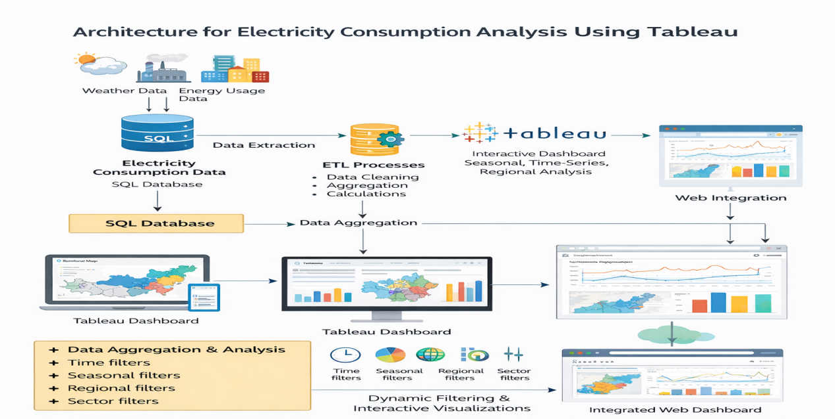

5. PROJECT PLANNING & SCHEDULING
Week | Task
1 | Data collection and understanding
2 | Data cleaning and preprocessing
3 | Tableau visualization development
4 | Dashboard and story design
5 | Testing and documentation

6. FUNCTIONAL AND PERFORMANCE TESTING

6.1 Performance Testing
The dashboards were tested across different devices and browsers. All visualizations loaded smoothly, filters responded quickly, and no performance lag was observed.

7. RESULTS

7.1 Output Screenshots
Dashboard 1: Plugging into the Future: Electricity Consumption Pattern Analysis
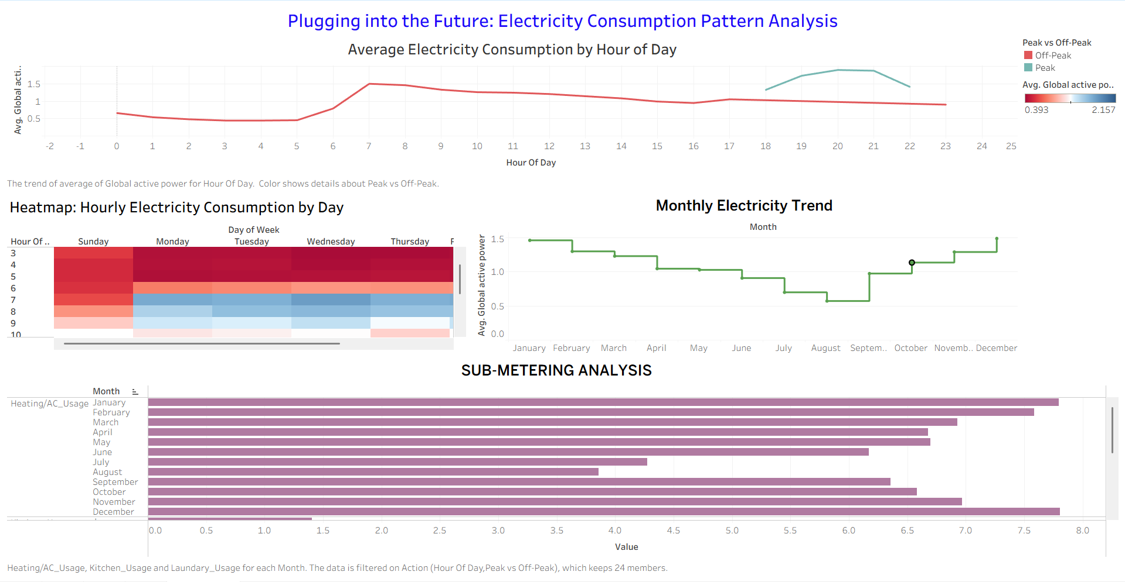

Dashboard 2 : Symbol Map Across Various States
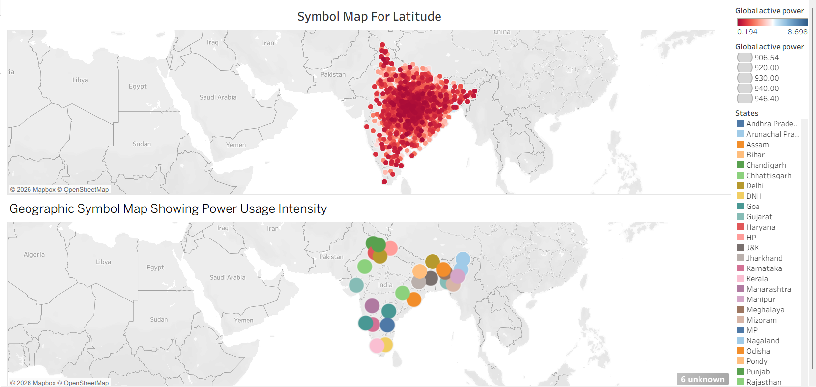
Story 1 : Time-Of-Day Usage Patterns
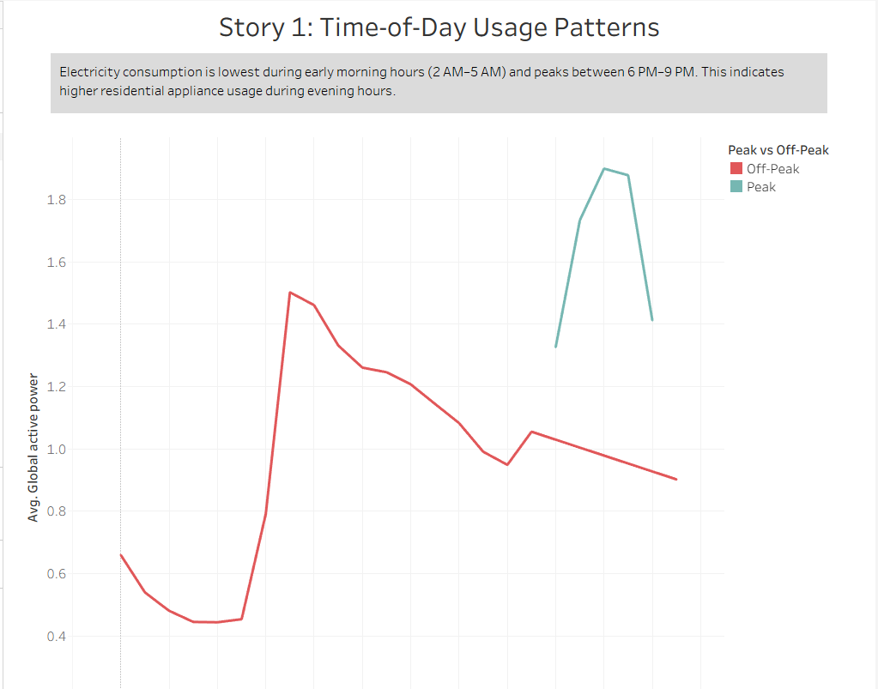

ADVANTAGES & DISADVANTAGES

Advantages

Easy-to-understand visual representation

Interactive filtering options

Supports energy planning and decision-making

Accessible through web integration

Disadvantages

Static dataset (no real-time updates)

No advanced AI-based forecasting

Dependent on data quality

9. CONCLUSION
The project successfully converts raw electricity consumption data into an interactive analytical platform using Tableau. The dashboards enable stakeholders to explore trends, understand demand patterns, and make data-driven energy decisions. This project demonstrates the effectiveness of data analytics in supporting sustainable energy management.

10. FUTURE SCOPE

Integration of real-time electricity data

AI-based demand forecasting

Smart meter data integration

Mobile-friendly dashboards

